Competitive Shooters of Lake Norman USPSA April 5th, 2026
COURSE DESIGNER: Ike Starnes
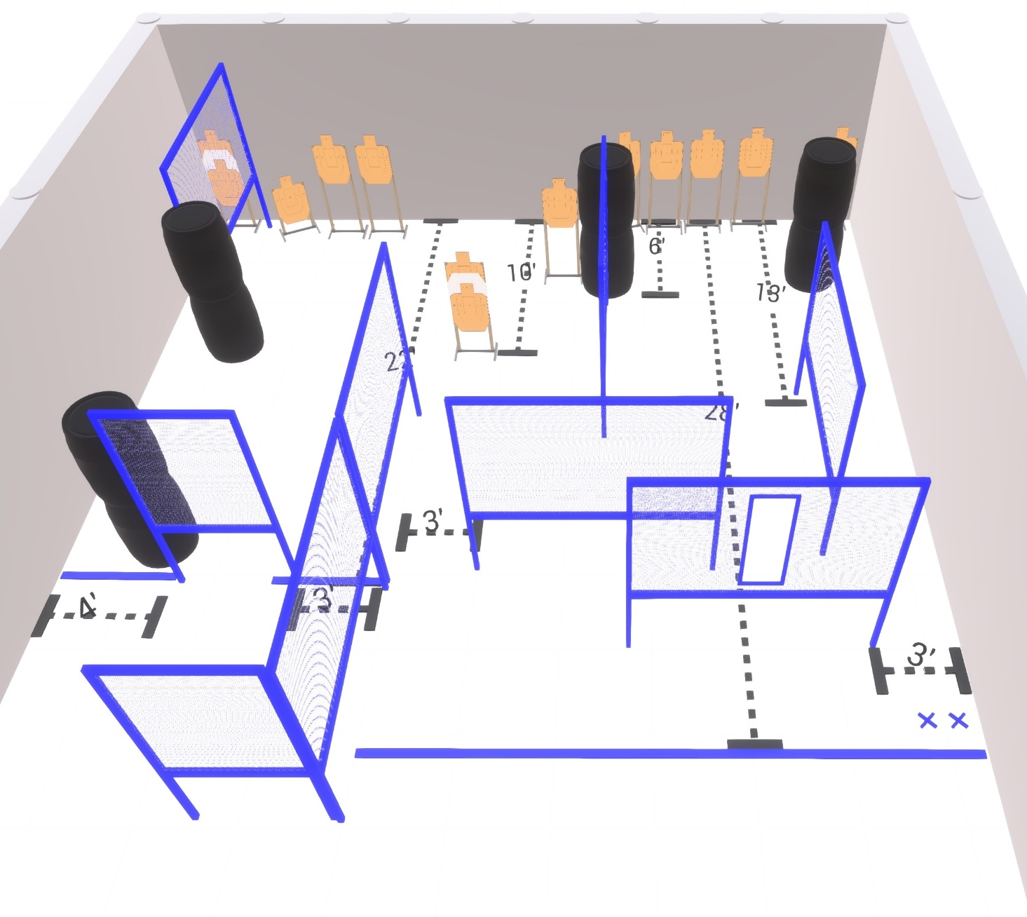

Stage 4 – Look Dave, I can see you're really upset about this.
26 rounds, 140 points, Comstock
There are 13 cardboard targets with some no-shoots.
Starting with both feet on the Xs.
Handgun is loaded and holstered. Wrists below belt.
PCC is loaded held in both hands stock touching belt.
On the audible start signal, engage targets from within the shooting area.

